# Objectives

* + You will configure local policy to use a WSUS server, perform updates on your Windows 10 system.

## Skills Reviewed

* + Configuring Windows service startup type.
  + Starting a service.

## New Skills

* + Configuring a Windows update using Local Group Policy Editor.
  + Downloading and installing Windows updates.

# Initial Conditions

Your virtual machine should be in this state prior to beginning this guided practice:

* + VCASTLE has a VM running Windows Server Update Server (WSUS). This WSUS is prepared with selective updates for Windows 10 and Server 2019 downloaded and approved for delivery.
    - The IP address for the WSUS server in VCASTLE is **10.254.7.2**.
  + Guided practice **Upgrade to Windows 10** completed.

# Final Conditions

At the end of this exercise, you will have:

* + Windows update service is started.
  + Windows update has downloaded and installed approved updates from WSUS.

# Instructions

1. Log onto **CLIENT1** with your administrative account.
2. Open **Local Group Policy Editor** by executing **gpedit.msc** in **Run**.

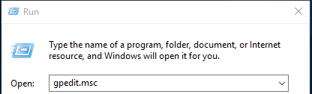

1. **Local Group Policy Editor** opens. In the Console tree, under **Computer Configuration**, expand **Administrative Templates > Windows Components** and click on **Windows Update**.
2. **Windows Update** opens in the **Results** pane.
3. Review the possible **Windows Update** configuration options.
   * 1. In the **Results** pane, click on the first item. Note that the **Setting**, **Requirements** and **Description** display in the area to the left of the settings. This is a quick way to view each item.
     2. Double-click on the first item. This brings up the edit dialog box for the policy item.
        1. Use the **Next Setting** and **Previous Setting** buttons. This is another way to view the policy. Click through a few of the settings looking specifically at the following:
           1. **Options:** box. Additional configuration options.
           2. **Supported on:**  Shows other Windows system that support the policy item.
           3. **Help:** List the detailed help for the policy item.
           4. **Not Configured / Enabled / Disabled** radio buttons.

**Not Configured:** The registry is not modified.

**Enabled:** The registry reflects that the policy setting is selected.

**Disabled:** The registry reflects that the policy setting is not selected.

* + - 1. Review each policy item.

1. Configure the policy to use the VCASTLE WSUS. Navigate to the **Specify intranet Microsoft update service location** policy item.
   * 1. Select the **Enabled** radio button.
     2. In the **Options:** box, in the **Set intranet update service for detecting updates:** text box and in the **Set the intranet statistic server:** text box enter **http://10.254.7.2:8530** and then click **OK**.

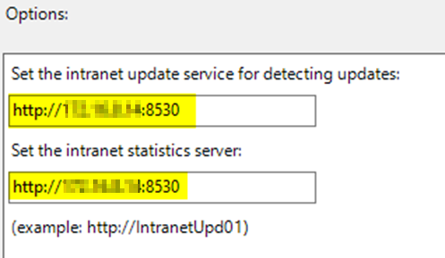

1. The **Windows Update** policy is a computer configuration. Computer policies apply during computer startup. Another method is to force the application of the policy.
   * 1. Execute **gpupdate /force** using **Run**. This will apply the policy.

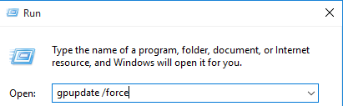

1. The **Windows update service** must be enabled and running. Open **Computer Management** and navigate to **Services and Applications > Services > Windows Update**. Double click on **Windows Update** service. **Note**: The service startup type should already be **Manual**.
   * 1. In **Startup type:** select **Manual** and then click **Apply**.
     2. Click **Start** and note that the **Service Status:** changes to **Running**.
     3. Click **OK** to close.
2. Open **Update & Security**. (**Start > Settings > Update & Security**).
   * 1. **Update & Security** open. Verify that **Check online for update from Microsoft Update** is unchecked. Click **Check for Updates**.
     2. Your system finds several updates for **Security**, **Malicious Software Removal Tool**, **Definition updated** for **Windows Defender Antivirus**. Download and installation follows.
        1. If your system has an issue with installing an update. Click **Retry**.

# Instructions

1. Viewing **Update history**.
   * 1. Click **View your update history** link.
     2. The **View your update history** page opens. Review Update history. Note that a **KB** number identifies each update. To what does this KB number refer?

# dOcument Work

1. On your VMHost system, **download** the ***GP07-WinowsUpdate.Test.ps1*** grading script from the assignment page to the **C:\Scripts** folder.
2. Check your lab to this point by running the following command:

Invoke-Pester -Path C:\Scripts\GP07-WindowsUpdate.test.ps1 -Output Detailed

1. You should not see any red in the output. Most of the time, the output will tell you what is wrong. If it is not obvious, contact your teacher and ask for assistance. **Correct** any **errors** you may have and run the script until all the output is green as shown in the figure. You should see the output below. Capture a snippet of the **output** **from** the **script** that shows the PowerShell Command output. Save the snippets as **update.png** for including in the report for this activity.

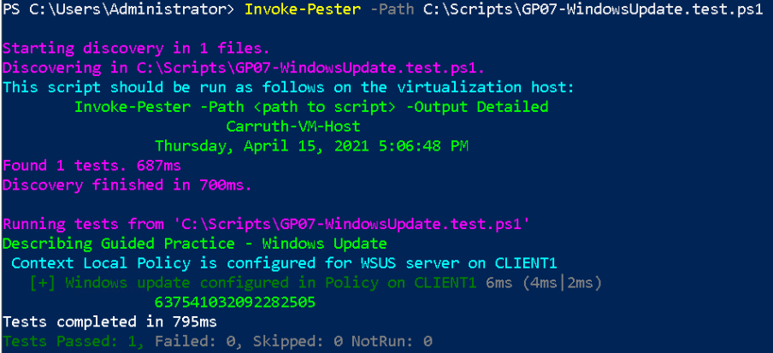

1. Add the **remote.png** image to the Guided Practice report and save the report as **Update_*Firstname*_*LastName*.docx** where ***Firstname*** is your first name and ***Lastname*** is your last name.
2. Upload the report as the submission for this activity.